**Matthew`s Games**

**A website with games made with HTML, CSS and JavaScript**

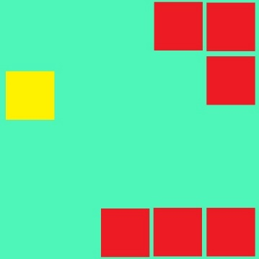

**Instructions to play**

When on the website, hover over the Play section in the navigational bar.

Choose a game from that list (space shooter does not work)

Always **open in** **new tab** for best game play experience

*Any questions please ask*

**Controls**

Not-so-Flappy Dot

* Dodge the red Blocks. You are the Yellow one
* Use the UP and DOWN arrows to move
* Press a number key (1, 2, 3, 4, 5, or 6) to start

Dot Man

* LEFT, RIGHT, UP and DOWN keys to move or WASD
* Collect the Green coins
* Avoid the Ghosts

MineSweeper

* Click on a tile and try to flag each mine. There are 13
* Right click to flag

*(Pressing space bar will allow to place a flag when you left click. Press space again to get off this mode)*

* Don’t click a mine or you will loose

Tetris

* Left and Right Arrow keys to move shape left or right
* Down arrow key to speed up going down
* Up, Z or X to rotate the shape

Snake

* Use the arrow keys to move
* Collect the red circles. They make you longer.
* Don`t hit yourself or the walls

Wordle

* Guess the correct 5 letter word. You have 5 guesses.
* Enter a real 5 letter word1 to guess.
* Click the start button at the bottom to begin. It does do stuff even if you think it is not.
* You have to type each individual letter in a separate input box.

Wack-a

* Click the start button and try to click the red square.
* Not a good game. Ideally, don`t play it.

1 = By ‘real’, I mean on of the 2500 or so words that the game recognises as a word. If you think there is a word missing that you would like added, please say to me.

Also, I’m sorry, but you have to type each individual letter in a separate input box